**Title of the project**

Author1 Author2Author3Author4 Author5

Affliation of authors

**Abstract:**

1. **Introduction**

**Heart disease describes a range of conditions that affect your heart. Heart diseases include:**

* Blood vessel disease, such as coronary artery disease
* Heart rhythm problems (arrhythmias)
* Heart defects you're born with (congenital heart defects)
* Heart valve disease
* Disease of the heart muscle
* Heart infection

Many forms of heart disease can be prevented or treated with healthy lifestyle choices.

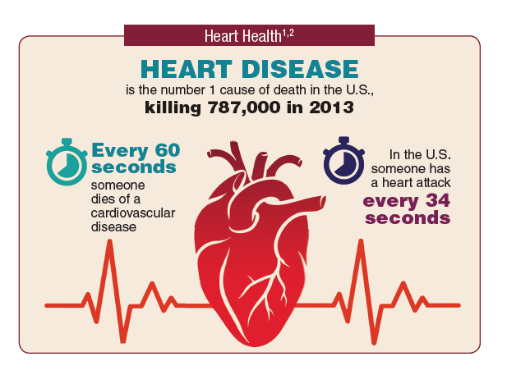

Heart diseases are often used in exchange for cardiovascular diseases. These kinds of diseases mainly refer to the conditions of blocked or narrowed blood vessels, resulting in a stroke, [chest pain](https://www.sciencedirect.com/topics/nursing-and-health-professions/thorax-pain) or [angina](https://www.sciencedirect.com/topics/nursing-and-health-professions/angina-pectoris), and heart attack. Other kinds of heart conditions, such as those affecting the rhythm, valve, or muscle of the heart, are other types of heart diseases. On the other hand, machine learning is crucial for determining whether anyone has suffered from heart disease. In either case, if these are predicted ahead of time, doctors would have a much easier time gaining crucial information for treating and diagnosing patients. Heart disease is mainly an incorrect symptom of [coronary artery disease](https://www.sciencedirect.com/topics/nursing-and-health-professions/coronary-artery-disease). It is also known as a cardiac disease; therefore, it is not with cardiovascular disease, which is any blood vessel disease.

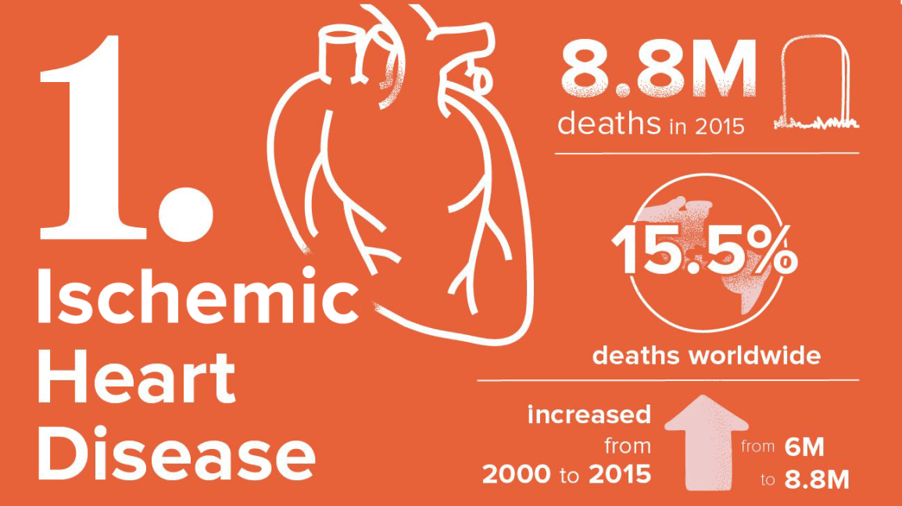

**//Heart disease, importance**

1. **Literature Survey**

**[1]author, database, classification, accuracy**

1. **Methodology**

Machine Learning (ML) is important in predicting the existence or absence of [heart arrhythmia](https://www.sciencedirect.com/topics/nursing-and-health-professions/heart-arrhythmia), locomotor disorders, heart diseases, and other conditions. It was expected well to provide significant insights to physicians, allowing them to adjust their diagnosis and care on a patient-by-patient basis. This project follows the **KNN algorithm** for developing heart disease detection, and this algorithm is used for the methodology to detect heart disease using Python.

A model regarding ML has played a significant role in creating accuracy and determining results with the aid of training data. This model is considered very significant due to its 84% (approximately) accuracy rate over training data

**Dataset, Classification algot**

**KNN-algo**

1. **Results**

**Precision**

**Recall**

**F1-score**

**Accuracy**

1. **Conclusion**

**References**

**1.** **https://www.kaggle.com/code/mohamedkhaled7/heart-disease-prediction-using-neural-networks**

**2.** **https://www.sciencedirect.com/science/article/pii/S2772442522000016#:~:text=Using%20Machine%20Learning%20algorithms%2C%20we,Classifier%2C%20and%20Random%20Forest%20Classifier.**

**3.**

**4.**

**5.**

**6.**